Convergence of the FE model – compared with an analytical model

In order to verify the formulation of the finite-element model, one must compare the numerically (FE) derived results with the few simple cases for which an analytical solution can be found.

One of the cases for which a nearly closed form solution can be found is for a simply supported beam.

From G. Genta "Vibration ..", page 87, equation 2-40. The free response of a simply supported Timoshenko beam is

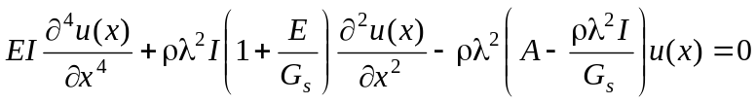

This equation has been solved by means of a mixture of symbolic and numeric procedures. The 'analytical' soluton was compared with an FE model partioned into a number of elements.

The comparison can by run by running the file testanax.m

From the plot below one can deduce that the error is decreasing (exponentially) with the increase in the number of elements (refined model).

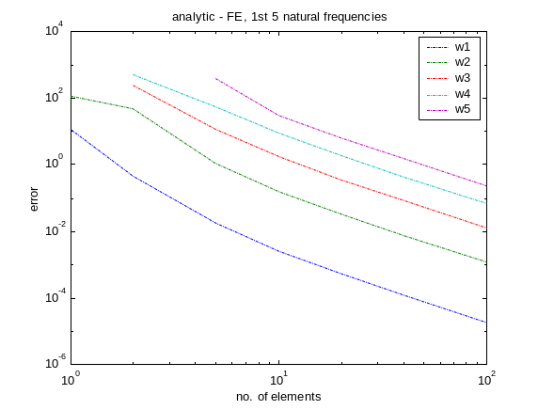
Figure 1: Convergence of the 1st 5 natural frequencies vs. no. of elements in the model

Matlab files to perform this test: testanax.m testanax2.m

